1.Program analysis
i. Task Description
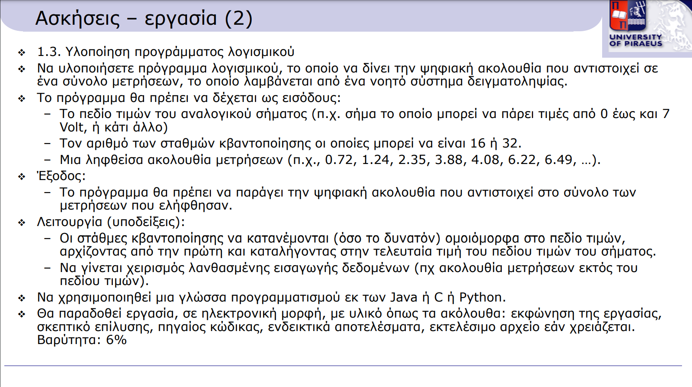

ii. Solution Rationale
Initially, the program requests user input for the following:
- The range of values,
- The number of quantization levels (16 or 32),
- The measurements.
For all three inputs, validity checks are performed. Specifically:
- The "last" value cannot be less than the "first" value when defining the upper and lower limits.
- Only 16 or 32 quantization levels are allowed; other numbers are invalid.
- Each measurement is checked to ensure it falls within the range [First, Last].
Next, the code:
- Stores the variables in a dynamic array,
- Rounds the measurements to integers and sorts them in ascending order,
- Calculates the group value for quantization,
- Determines the maximum length of the binary representation.
As output, the program displays the rounded measurements and their binary representation.

iii. Sample Solution
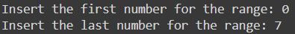
Input for the range of values:

Input for the quantization levels:

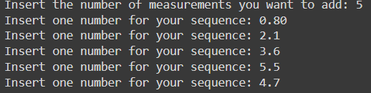
Input for the frequency values:

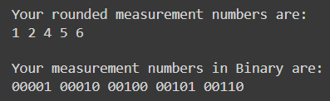
Results:

iv. Handling Invalid Input Cases
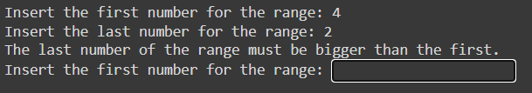
For the range of values:

For the quantization levels:
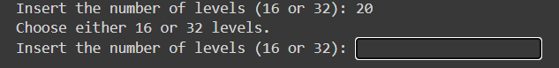

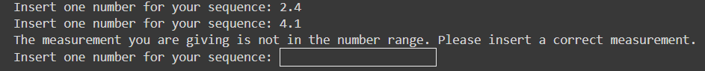
For the measurements:

